39th Question Activity and Class diagram:

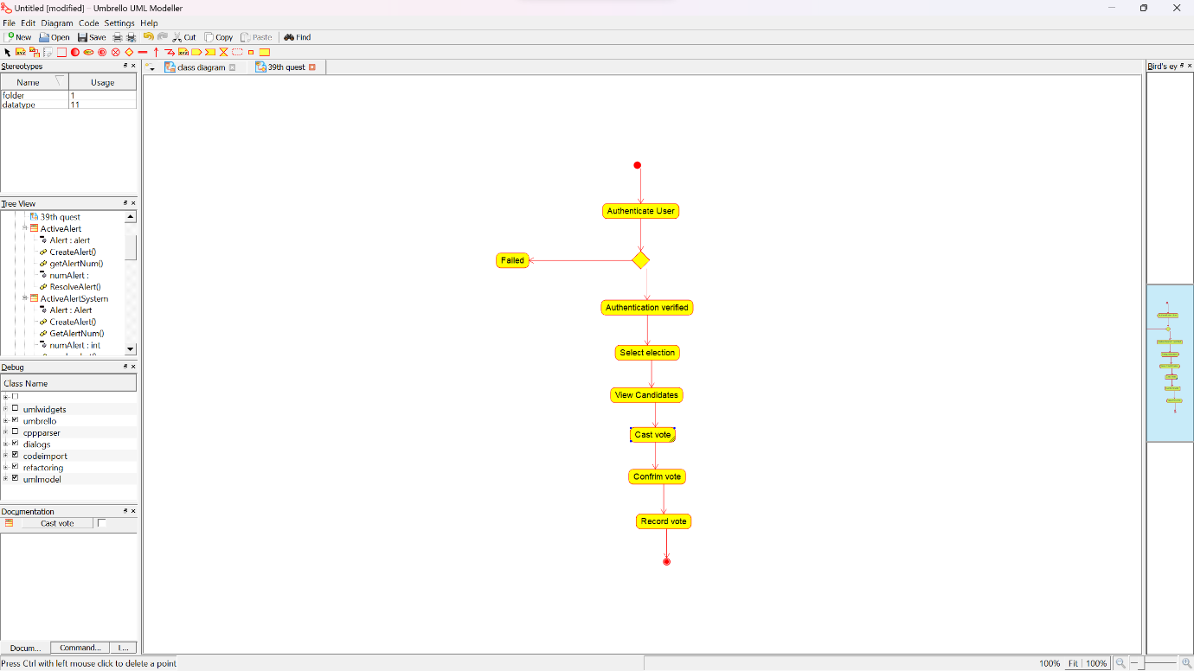ACTIVITY DIAGRAM:

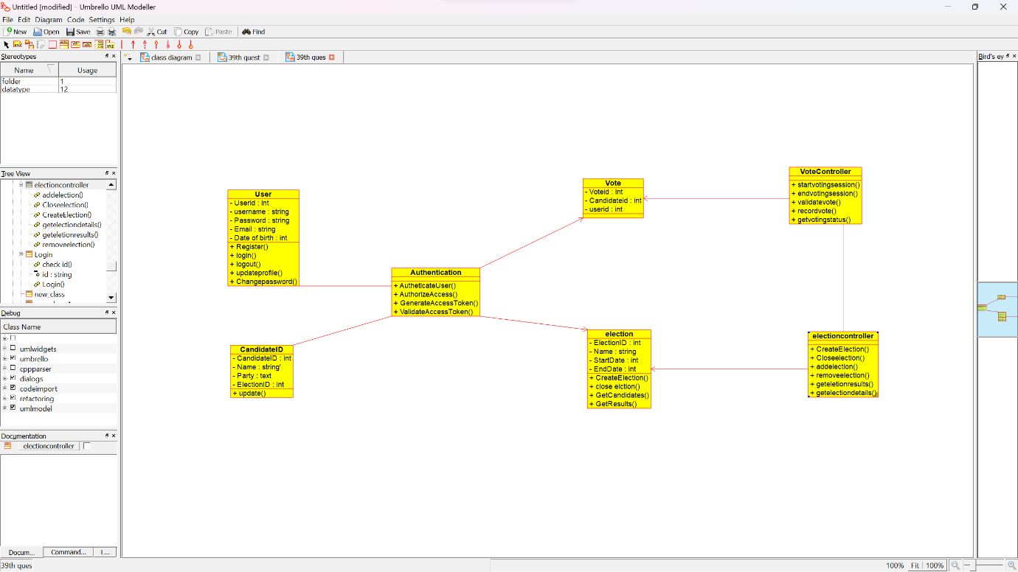CLASS DIAGRAM:

AIRLINE RESERVATION USE CASE DIAGRAM:

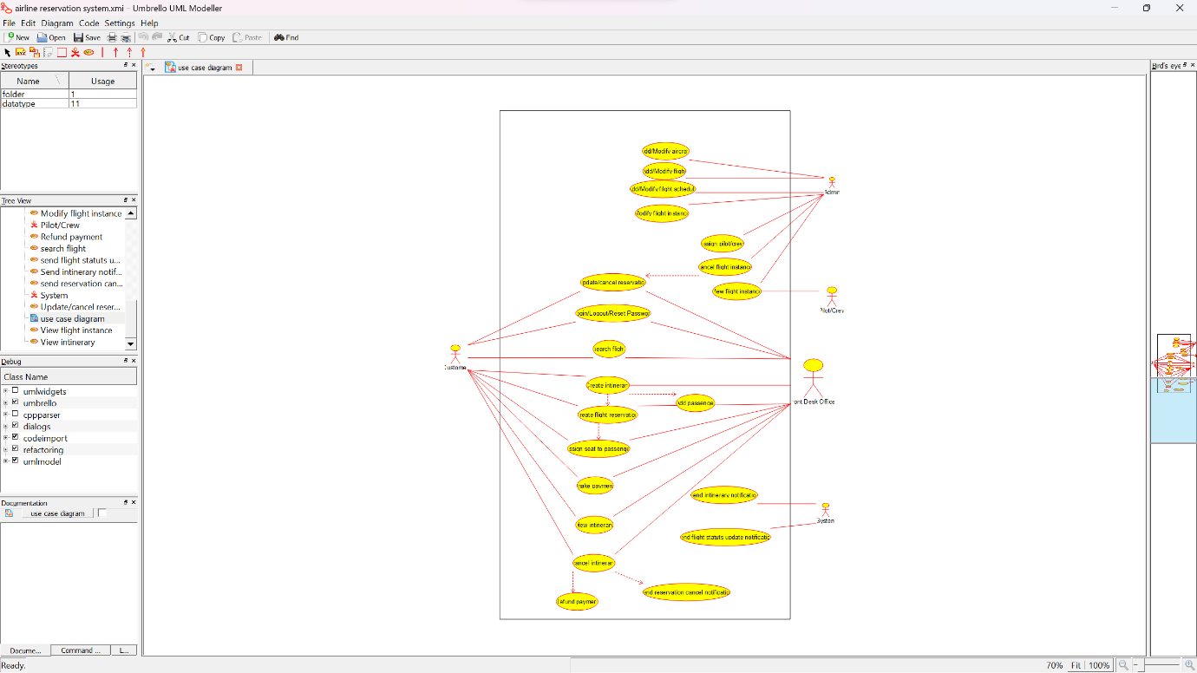

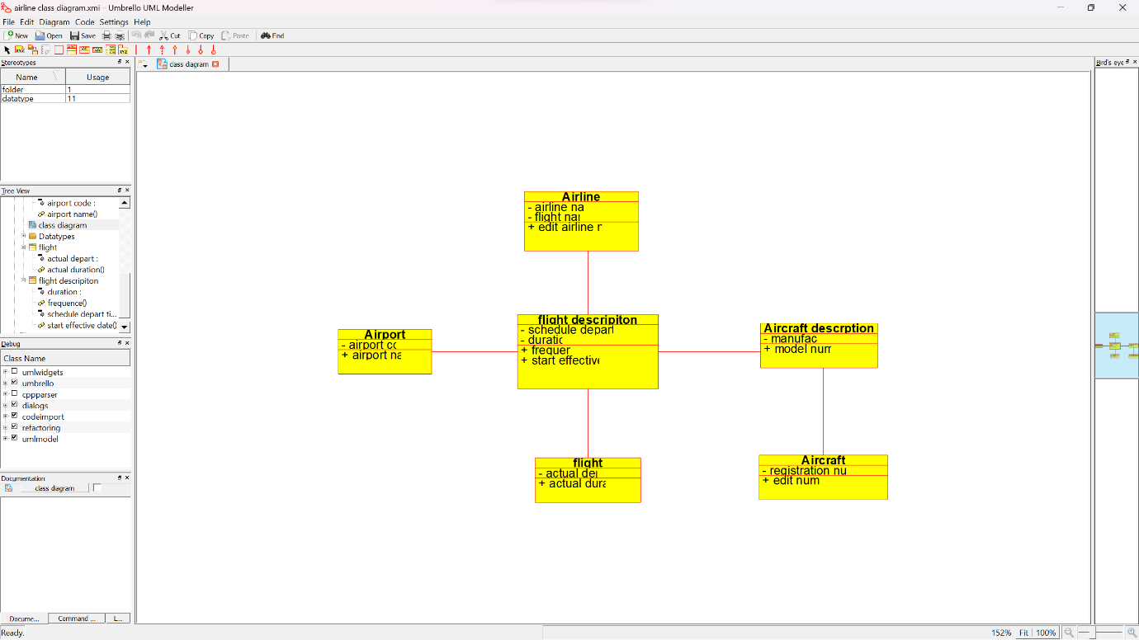AIRLINE RESERVATION CLASS DIAGRAM:

E-WALLET USECASE DIAGRAM:

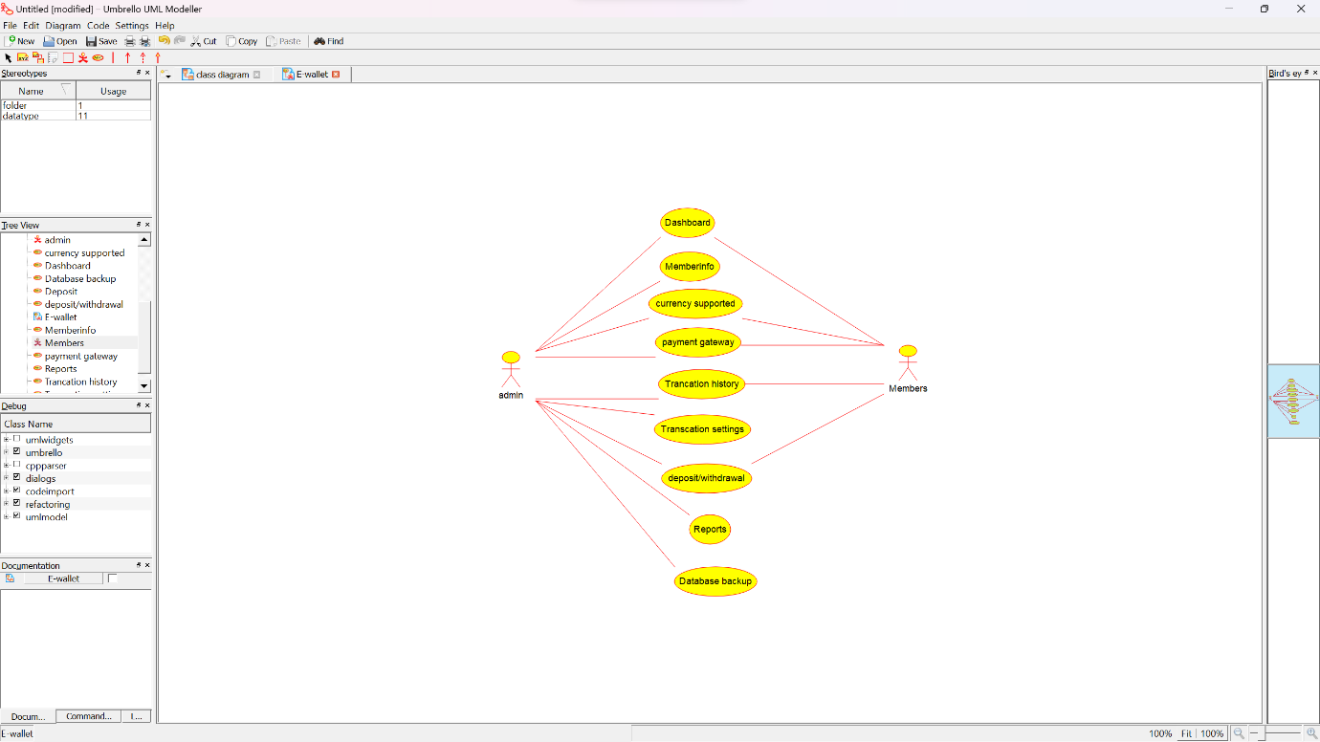

ONLINE SECURITY SYSTEM MANABGEMENT CLASS DIAGRAM:

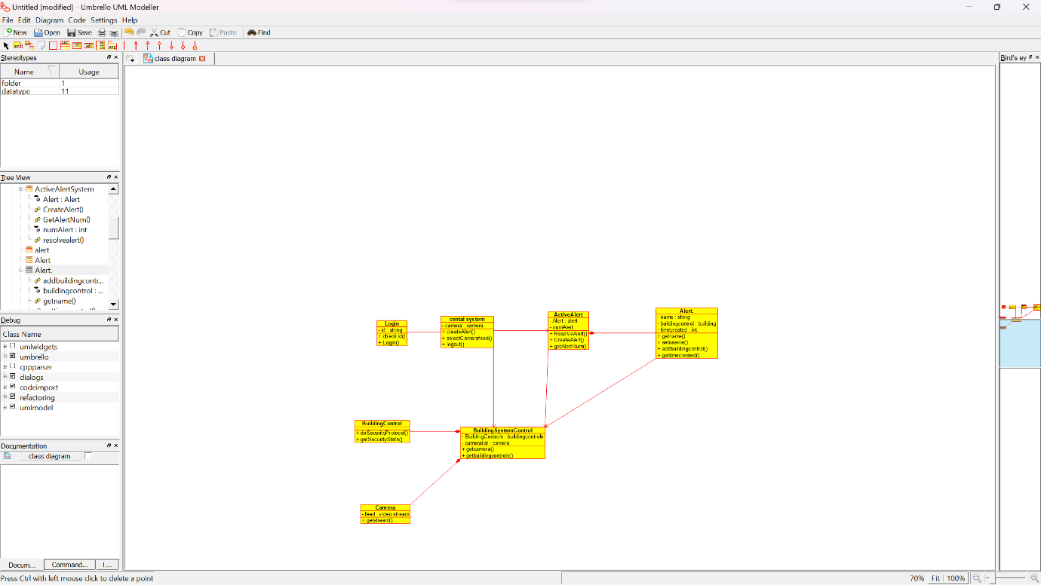

SHOPPING CART SYSTEM USE CASE:

